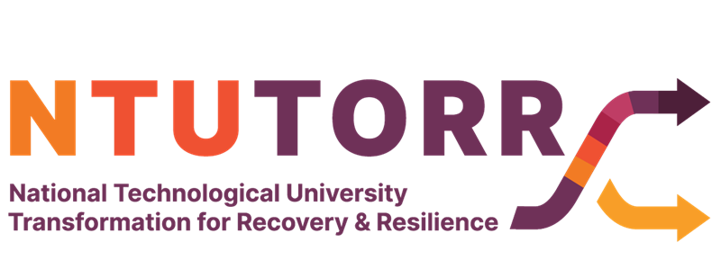

Fellowship Application Form

Students as Partners in Innovation and Change Fellowship Programme
This is a wonderful opportunity for students and staff to collaborate on projects that improve the student experience within their own institutions. These projects might be focused on a specific module, programme or discipline or might be campus or institute-wide. Each project must address at least one of the themes below and should result in a positive change that can be sustained.
Digital Transformation in Teaching and Learning Education for Sustainability
Equality, Diversity & Inclusion Universal Design for Learning (UDL) Academic Integrity and Assessment

100 Fellowship Projects available to the Technological Universities and Institutes of Technology
Fellowship Project Value: up to 5,000 euro per project

Note: Project teams must involve staff and students. Teams must include a minimum of 3 members and at least 2 students.

There are two options to consider when applying:
Students and staff apply together who have a proposal for a project they would like to collaborate on under any of the themes outlined above.
Students can apply who may not have a staff partner yet, but would like to register their interest in forming a project team and being assigned a staff partner to collaborate with.

Closing date for applications January 30th, 2023
All applications will be anonymously reviewed by a panel of evaluators that includes learning and teaching experts and SU representatives.

Project timeline: It is expected fellowships will be awarded in February 2023. Projects will

commence from March 2023 and conclude by April 2024.

All fellowship projects will be disseminated in a national symposium in 2024 to celebrate the Student Partners for Change and Innovation Fellowship Scheme.

Selection Criteria:

Projects will be assessed on rationale and relevance to theme/s, approach to partnership, inclusiveness, student success outcomes, project plan, impact and sustainability. The assessment rubric is available at http://www.thea.ie/ntutorr Projects will be selected to ensure a balance across themes.
Individual student applications will be assessed on (engagement with a theme, reflection on own experience as a learner, commitment to enhancing the student experiences.)
The selection process will aim for gender balance in the fellowships awarded. Applications from all staff and students are encouraged and particularly from under- represented students.

The NTUTORR project is committed to creating an inclusive environment where diversity is celebrated, and everyone is afforded equal opportunity. We welcome proposals from all staff and students at the eligible institutions and strongly encourage under -represented students to submit proposals either individually or as part of a team. The National Access Plan specifies the following groups:
Students who are economically disadvantaged,
Students who are members of Irish Traveller and Roma communities Students with disabilities, including intellectual disabilities.
* Required

- The data you provide will be used for the purposes of administering and reporting on the Fellowship scheme only. The data will be held securely, in digital form by the central project office. Only the NTUTORR project team will have access to the data. It will be destroyed after the final report on the Fellowship scheme is completed and no later than the 31st of December 2024. The applications will be anonymised before being reviewed and scored by an evaluation panel. *
After an application is submitted, individual student applicants will be sent a link to a short, anonymous Equality, Diversity and Inclusion (EDI) monitoring form. For team applications, team leads will be asked to forward the link to all student members of the team.

I consent to my data being used for the purposes described.

- At which Technological University or Institute of Technology do you work or study? *

Atlantic Technological University (ATU) Dundalk Institute of Technology
Dún Laoghaire Institute of Art, Design and Technology (IADT) Munster Technological University (MTU)
South East Technological University (SETU) Technological University Dublin (TUD)
Technological University of the Shannon (TUS)

- This application is from *

A member of staff A student

- Proposal Title: *

- Name of Project Fellowship Leader: *

- Email for lead contact *

- Number of students in the team (please enter digits rather than words) *

- Number of Staff in the team (please enter digits rather than words) *

- Please indicate the gender breakdown of the team *

- Indicate the programme/module/service/process that will benefit from this fellowship award: *

- Please select which of the following themes your project proposal best aligns with: *

Digital Transformation in Teaching and Learning Education for Sustainability
Equality, Diversity & Inclusion

Universal Design for Learning (UDL) Academic Integrity and Assessment

- Project deliverables *
Briefly outline the key outcomes, changes and/or benefits anticipated, linking to the themes and the context of the project. Briefly explain how these will enhance the student experience. (200 words max) 10 points

- Proposal Description of the Project (max 300 words) 10 points *
Provide a short summary that includes the aims, structure, timescale and key activities

- Outline the approach to student partnership that will be taken. Briefly explain how the principles of student engagement will inform the project and how partnership will be enabled (see Steps to Partnership
| NStEP (studentengagement.ie)). (max. 300 words) 10 points *

- Outline the steps taken to promote inclusive opportunities for partnership in this project. Explain how the project has considered potential barriers for students in terms of the promotion/recruitment to the project and participation and engagement in the project (e.g. time, costs, location etc). What steps have been taken to enhance inclusiveness? 10 points *

16. Outline the proposed budget for the project. 5 points *

17. Please provide details of the anticipated impact on the student learning experience and teaching enhancement. Identify the nature of the change/benefit within the context of the module/programme/service/institution/process and identify what success will mean. Briefly outline how the impact will be sustained/developed. (300 words) 10 points *

18. Approximately how many students (please provide a number only) will benefit initially from the impact of the project? For example, changes to a module will benefit those taking the next iteration of the module, a change to induction will benefit all incoming first years and so on. *

- At what stage are you in your studies? *

1st year 2nd year 3rd year 4th year
Postgraduate

- Your name *

- Your email address *

- Are you *

Full-time Part-time

- Are you a mature student? (23 years or older when on January 1st of the year you applied to enter your course) *

Yes No
Prefer not to say

- How would you describe your gender *

Female Male
Non-binary In another way
Prefer not to say

- What motivated you to apply for this fellowship? Tell us why you are interested in this opportunity, what you would like to get from it and what you would like to contribute. (200 words max.) 20 points *

- Drawing on your own experience as a learner so far, what do you feel are the key small changes that could enhance the student experience? (300 words max.) 20 points *

- Which of the themes below interest you the most? *

Digital Transformation in Teaching and Learning Education for Sustainability
Equality, Diversity & Inclusion

Universal Design for Learning (UDL) Academic Integrity and Assessment

- Why are you particularly interested in that theme? Tell us why you think it is important, particularly with respect to your institution or discipline (200 words max). 10 points *

- What support would help you to engage with the project? (e.g. blended approach, flexibility, assistive technologies etc.)? *

- Is there any other information you feel is relevant? *

This content is neither created nor endorsed by Microsoft. The data you submit will be sent to the form owner.
Microsoft Forms

